[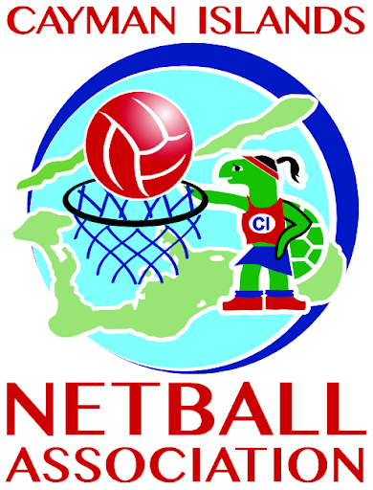](https://www.google.com/url?sa=i&url=http://www.caymannetball.com/&psig=AOvVaw2q7MDUppKxanycnvbm6xtA&ust=1590107911495000&source=images&cd=vfe&ved=0CAIQjRxqFwoTCJjMyt3bw-kCFQAAAAAdAAAAABAS)

Welcome!

Welcome to CINA's new newsletter! This publication will be used to keep all CINA stakeholders in the loop about how Netball is being managed in the Cayman Islands. We will also feature any notable events in the sport at home and abroad.

We invite all CINA members to get involved with the newsletter by submitting any newsworthy information to the association via email at Caymannetball@candw.ky. Also, look out for our new and improved website coming soon!

*HOME TRAINING DURING QUARANTINE*

*INTERNATIONAL NETBALL NEWS*

*LOCAL CLUB FEATURES*

*COVID-19 UPDATES*

*CINA ELECTS NEW BOARD*

What’s New?

P.O. Box 1915

George Town, Grand Cayman, cayman islands

email: caymannetball@candw.ky

Telephone: +1(345)916-1944

**05**

**04**

**03**

**02**

**01**

NEW BOARD TO SERVE CINA

The Cayman Islands Netball Association began 2020 with several newly elected board members. The board continues to be headed by well-seasoned President, Lucille Seymour, who will be closely assisted by Norma Ferryman (1st Vice President). Newly elected board members are Katherine Gow (2nd Vice President), Lyneth Monteith (Special Director) and Tishelle Logan (Secretary). The CINA board received no nominations for Treasurer and are therefore inviting qualified members to apply. Accountant Alan Mark Fraser will be acting as Treasurer until the post is confirmed. Also working closely with the board on special projects are Nicardo Stanbury and Andrea Singh.

The new executive board has met twice since its appointment to discuss and implement the new Constitution. Clubs will be invited to a webinar in the near future where further information will be shared. Protocol and regulations are currently being drafted for dissemination so that everyone in Netball can be aware of what guides their actions as a member of CINA. The board is also currently engaged in 'Effective Governance' training facilitated by consultant Karl Murray. Governance is an important aspect that is being reshaped by CINA.



COVID – 19

UPDATES

On the 13th March, 2020 Grand Cayman saw its first confirmed case of COVID-19 which led to the closure of several sectors of the country as the government sought to enforce social distancing. This, of course, led to the suspension of all sporting events and team activities.

The Cayman Islands National Senior and Junior Netball squads continue to work on fitness as a team via ZOOM online meetings. CINA encourages all netballers to stay fit while adhering to social distancing protocol and released a video in support of this message (left).

For the latest updates on COVID-19 in the Cayman Islands click [here](http://www.gov.ky/coronavirus).

local club features

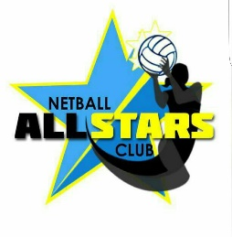**All Stars Netball Club**

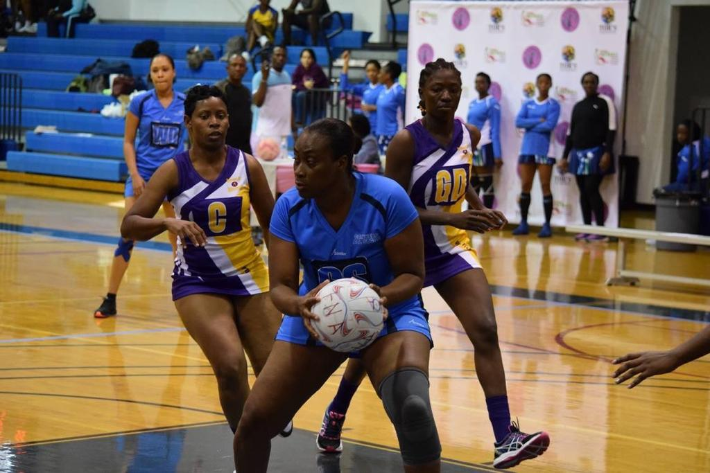

Founded approx. 20 years ago.

Club President: Lyneth Monteith

Training Times: Monday / Wednesday 6:30pm-8pm John Gray High School

All Stars Netball Club is a long -standing club with a successful history. This comes from hard work on and off the court and a very cohesive unit. We have an A and B adult team, an Under 14 and an Under 12 team who are all registered and participating in the local leagues.  All Stars Netball Club has approximately 45 members.  The adult players travel overseas annually to the Miami Classics in Florida.

Past and present members of the Club have been called to National duty representing the Cayman Islands Netball Association.  Presently 7 members of the senior adult team are National squad members.  Kay Copeland, an All Stars Club member, received the Top Shooter award in the 2019 Netball Europe Challenge tournament in the Isle of Man and the 2019 Four Nations tournament in St. Maarten.

At this current time, training is suspended but we are staying in regular contact and some of the squad members are doing online classes hosted by an elite UK netballer as well as other agencies and trainers.

Netball is a wonderful way to make new friends whilst keeping fit. We would love to have new members and would encourage anyone to get in touch to the contact below.

Lyneth Monteith

Telephone: +1 (345) 925-4337

Email: Lynmonteith@hotmail.com

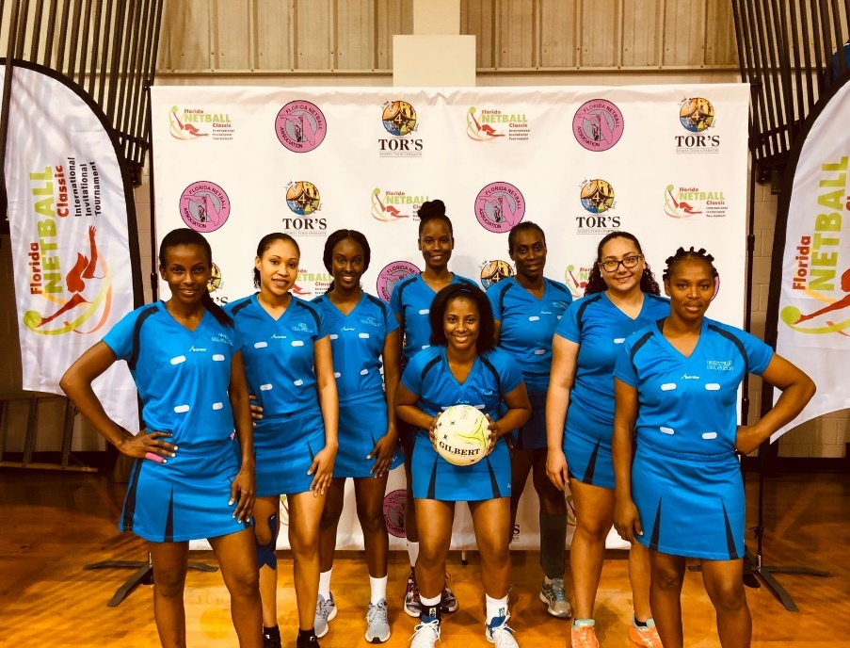

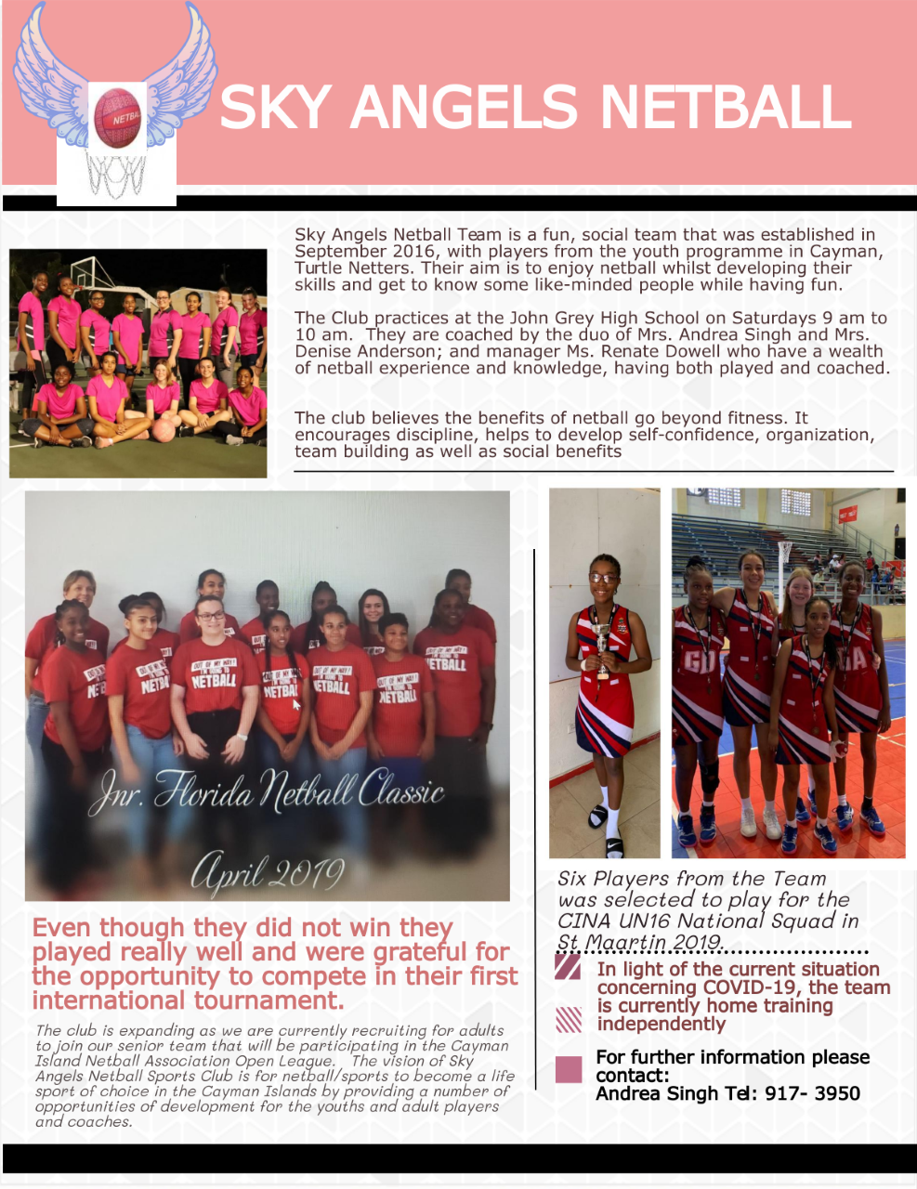**Sky Angels Netball Club**

**NATIONAL TEAM UPDATES**

* The Senior National Netball Team was invited to Gibraltar and Singapore to participate in world ranking tournaments. However, due to the COVID-19 pandemic, these tournaments have been postponed until further notice.
* National Team fundraisers have also been postponed until shelter in place restrictions are lifted. All tickets previously purchased for the Cash-O-Rama remain valid; new draw date to be announced.

International Netball News

* The Jean Pierre Caribbean Youth Netball Tournament (JPCYNT) in which the Cayman Islands National U16 squad was due to participate, has been cancelled. Caribbean Netball Association has proposed that the tournament be held in 2021 and be open to all girls Under 17, allowing those on the cusp of the cut off age in 2020 to participate in 2021.
* The JPCYNT will be hosted by the St. Vincent and the Grenadines Netball Association
* CINA to attend the Caribbean Netball Association’s Annual General Meeting on 6th June, 2020
* INF is offering a chance for your Netball team to be featured in their newsletter and win Gilbert Netball stash! Simply share your isolation videos or activities, tag the INF, or use the hashtag #NetballFamily. Winners are chosen weekly. Find out more by clicking [here](https://netball.sport/social-media-competition).

CINA ENCOURAGES YOU TO STAY SAFE AND ACTIVE!

Here are some videos to help you stay fit and avoid packing on extra pounds during quarantine!

Netball fitness workout four week challenge: [Session 1](https://www.youtube.com/watch?v=asSLL0fOFnE), [Session 2](https://www.youtube.com/watch?v=Swc3uAzyDHs), [Session 3](https://www.youtube.com/watch?v=nEgp9xILr0w), [Session 4](https://www.youtube.com/watch?v=FbF6QTd80pc&t=35s)

Click [here](https://www.youtube.com/watch?v=LeKBkL-1M-s) for a 20 minute HIIT Netball workout!

***While in quarantine, why not learn some new coaching skills?!***

Click [here](https://www.sportplan.net/drills/Netball/) to sign up to Netball Coaching Made Easy for free!